**💕Packet Sniffing with TCPdump💕**

📌use **ifconfig** to see your network interfaces on Linux

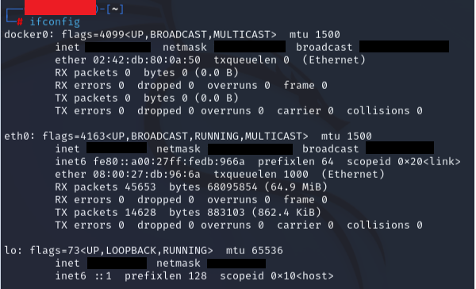

📌For this example, I chose eth0, the LAN (local area network) interface

📌 The command **-i** is used to select the interface, **-n** to show raw ip addresses, and **-v** for verbose (show detailed information)

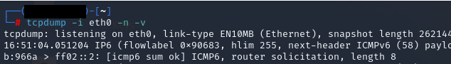

📌You can open a browser normally, and on the prompt command you’ll be able to see many packets being captured by TCPdump, as shown on the next image

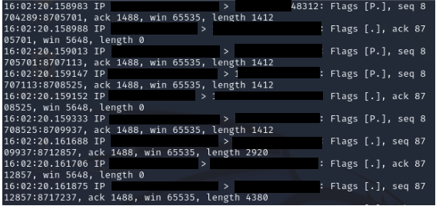

📌In case you want to save the results of the sniff in a file, you can use the command **-w**

📌 The format .pcap used in the example stands for packet capture

